Mathew Block is Communications Manager for the International Lutheran Council. He is also editor of The Canadian Lutheran magazine, and formerly served as Communications Manager for Lutheran Church–Canada.
https://ilc-online.org/author/matthewblock/
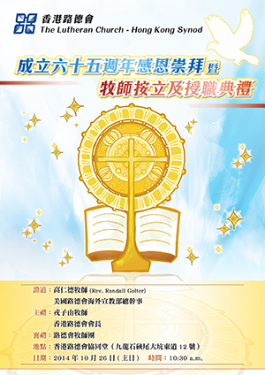
A poster from the LCHKS’ 65th Anniversary Celebration Service.

HONG KONG – The Lutheran Church–Hong Kong Synod (LCHKS) celebrated 65 years of ministry at a Thanksgiving Service October 26, 2014 in Kowloon, Hong Kong. The event also marked the ordination of eight new pastors—a record number for one year in the LCHKS.
President Allan Yung of the LCHKS recently gave an interview to Lutheran Radio UK where he discussed the history and present work of the church in Hong Kong. Missionary activity from The Lutheran Church—Missouri Synod (LCMS) began in China a century ago (an event the LCHKS celebrated last year), but missionaries were forced to leave the mainland in 1949. LCMS missionaries who evacuated to Hong Kong, a city at the time that was much smaller and poorer than it is today.
“It was still a very small place—less than half a million people,” President Yung notes. “Most of them were refugees. They were very poor. They needed material support and spiritual support—they were very hungry.” The Lutheran missionaries requested to stay and serve permanently in Hong Kong, a request that was granted. “Since then, a lot of work has been carried out,” President Yung said. “Now we are a city of seven million people.”
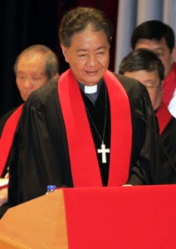
President Allan Yung at a 2013 service celebrating 100 years of Lutheran witness in China.

President Yung entered office in 1997, the same year Hong Kong was transferred to the authority of the Chinese government. While at the time some Westerners worried what impact that might have on Christian witness in Hong Kong, President Yung is happy to say that the mission of the church continues to flourish.
Today, the LCHKS has 10,500 communicants, 36 congregations, six mission stations, 40 schools, 45 social service centres, and other agencies like a seminary, counseling services, and more. In total, the church has more than 130 service units throughout Hong Kong.
That strong push towards community service brings with it an opportunity for Gospel witness. “We have 20,000 students studying in our schools,” President Yung explains, “and about 90% of them are not Christian. So we build up in all our schools a mission station, and some have become congregations already. So they are fed not only worldly knowledge but also spiritual knowledge.”
The same is true of social service projects. “We share our earthly things with people because that’s what Jesus wants,” President Yung notes. “We want to share the love of God with them. The people understand that this comes from a church, and it is very well received by the public.”
The respect the church has gained because of its education work has led in recent years to unique opportunities. The LCHKS is now starting an English school in Shenzhen, a neighbouring city in mainland China. President Yung notes that they are also working with the national church there to offer an English-language Sunday service.
These opportunities are possible because the church is careful to avoid politics. “We don’t want to get ourselves into political issues,” President Yung explains. “We just want to be involved in Gospel issues and service issues, so we can grow and move forward in Hong Kong. We want to have a good relationship with the authority in Hong Kong as well as the authority in mainland China.”
The church also has good relations with other Christians. The church works with other Christians in Hong Kong on external matters (like disaster relief, for example), but is careful to defend its confessional Lutheran identity. The LCHKS is known locally as a conservative church because of its strict adherence to biblical teachings on issues like female ordination, President Yung notes, but he clarifies that “we are a growing conservative church.” “We are most grateful to be able to say that,” President Yung continued. “We have a constant growth of about three to five percent membership a year.”
The LCHKS has a strong relationship with Christians around the world as well. The church retains close ties to the LCMS, its mother church, and further sits as a member of the International Lutheran Council.
https://ilc-online.org/2014/11/12/hong-kong-lutherans-celebrate-65th-anniversary/

100 Years of Confessional Lutheran Witness in China
Dec 19, 2013
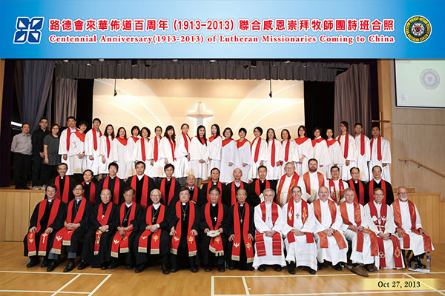
Participants in the 100th anniversary celebrations.

HONG KONG – On October 27, 2013 The Lutheran Church-Hong Kong Synod (LCHKS) celebrated 100 years of confessional Lutheran witness in China at a special service at Concordia Lutheran Church (Yau Yat Chuen) in Kowloon.

President Allan Yung addresses the assembly.

Numerous Chinese and American pastors participated in the centennial service, with Rev. Dr. Jeff Oschwald of Concordia Seminary (St. Louis, Missouri) preaching. The LCHKS’ President, Rev. Dr. Allan Yung, was also present, bringing greetings to the assembly of 1,200 gathered on the festive occasion. He expressed thanks for those missionaries who established a mission culture in the region, and encouraged the congregations of the LCHKS to continue putting the Great Commission into practice.
The Centennial Anniversary of Lutheran Missionaries Coming to China service recognized Rev. Edward Arndt’s 1913 arrival in China. Rev. Arndt, a pastor of The Lutheran Church—Missouri Synod (LCMS), moved to China one hundred years ago to share the Gospel. His work led to the establishment of churches and schools in the area of Hankou, China, where he passed away in 1929.

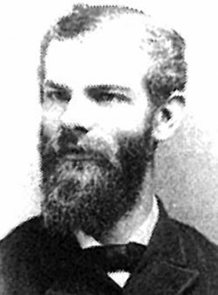
Rev. Edward Arndt

Rev. Arndt was also instrumental in the establishment of The Lutheran Church—Missouri Synod’s mission work in China at large. Following the Chinese Civil War, when Christian missionaries were forced to leave the country, LCMS missionaries moved to Hong Kong to minister to refugees there. That led to the founding of The Lutheran Church-Hong Kong Synod, which in time grew to become a self-governing, independent church body.
Today, The Lutheran Church-Hong Kong Synod has 34 congregations, 8 mission stations, 40 schools, and 43 social service units. It is a member church of the International Lutheran Council.
For more information on the history of Lutheran outreach in China, watch this video from The Lutheran Church-Hong Kong Synod.

https://ilc-online.org/2013/12/19/100-years-of-confessional-lutheran-witness-in-china/

來華佈道百年回顧短片 旁述:高德惠先生(揚子江上路德人作者)
知罪由律法，稱義本福音。
https://www.youtube.com/watch?v=r9El_brFsv4

